**Digital Technologies – DTE2U**

**Evidence Document – Develop a digital outcome AS91893 and AS91897**

**Part 1: Decompose your digital outcome**

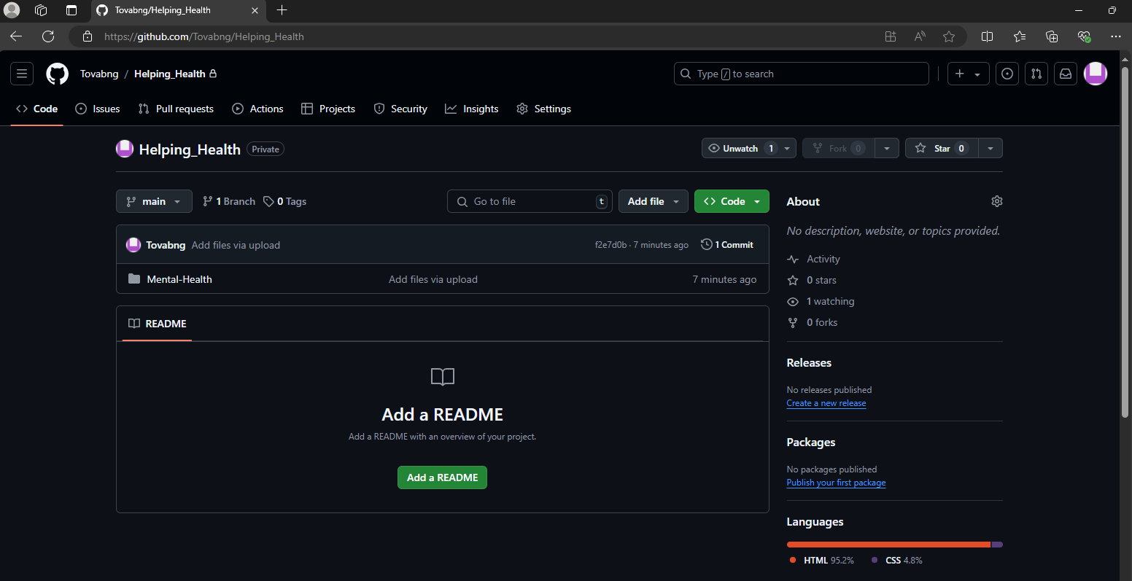

This image above is evidence of an unsuccessful upload to github … showing how I wasn’t able to upload it on to github

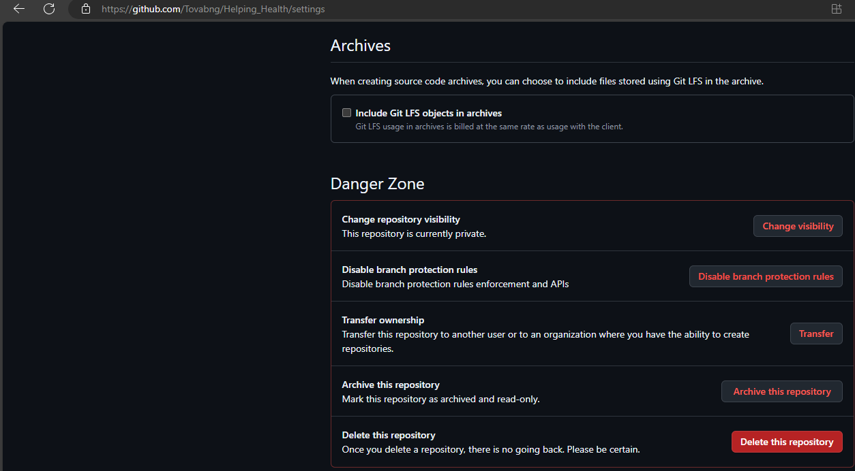

This image above shows how I deleted the repository since it wasn’t able to upload on to github

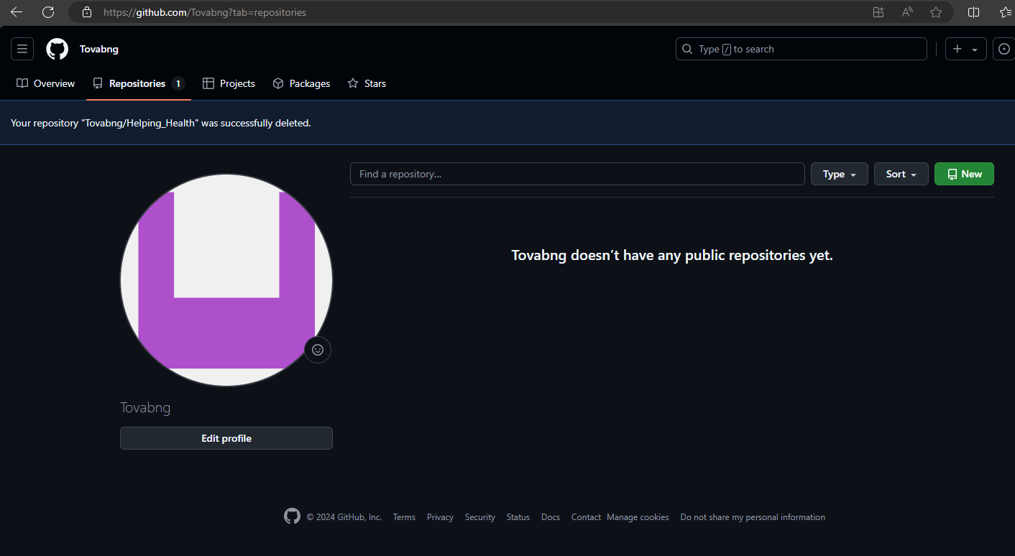

This image above shows that I didn’t select public when I created my first repository which was a mistake I did.

**Part 2: Project Management.**

**Part 3: Develop/Trial components.**



This image above shows my unsuccessful attempt at uploading my file on to github due to me putting the repository on private instead on public

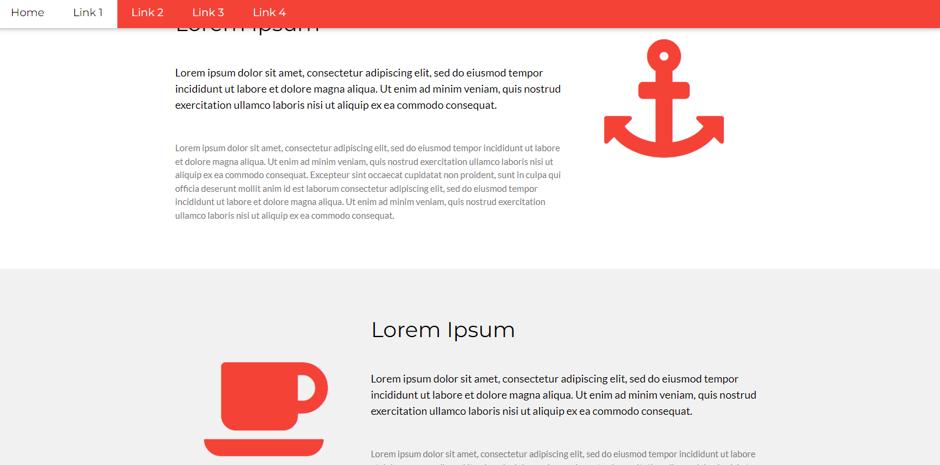

This a photo of a coffee cup and an anchor. These two emblems were a challenge to remove during my time creating the website as I tried multiple ways of trying to remove it but it didn’t quite work out for me. That was until my teacher found a way to remove it and showed me how to.

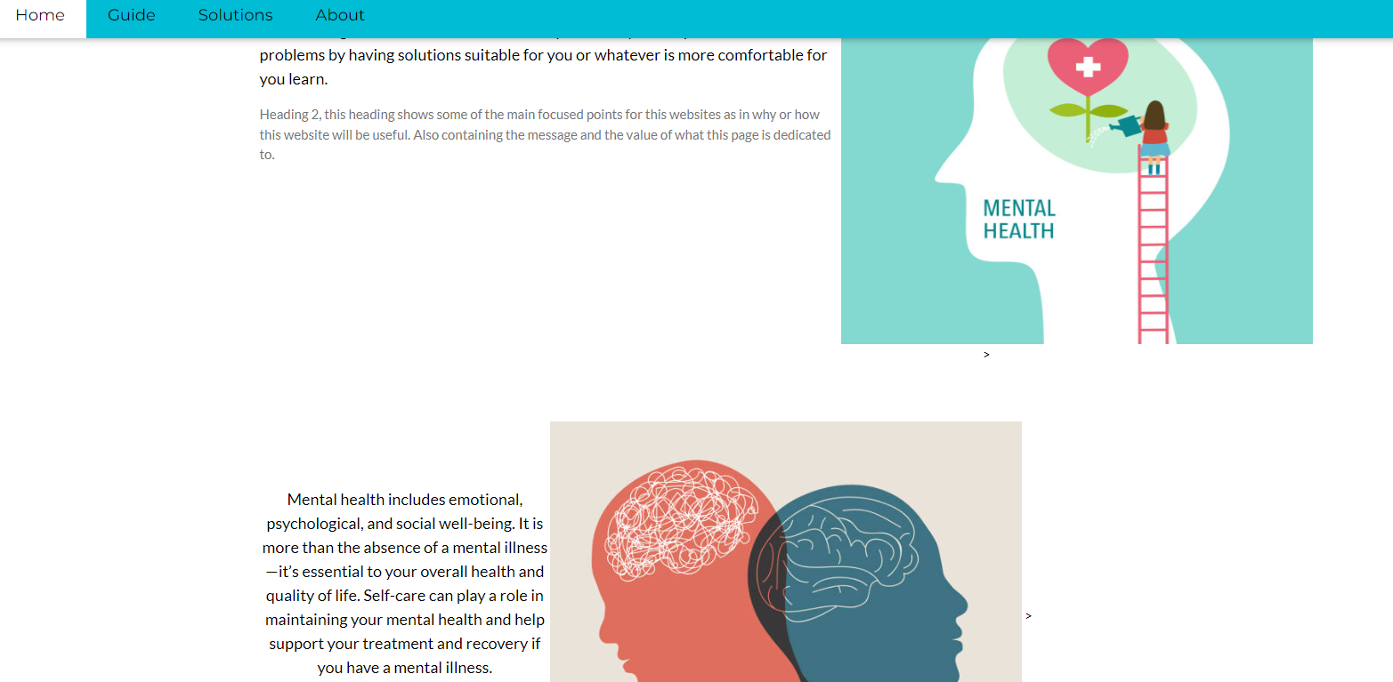

This is the aftermath of me removing the coffee cup and the anchor and switching to photos instead that related to my topic which is mental health

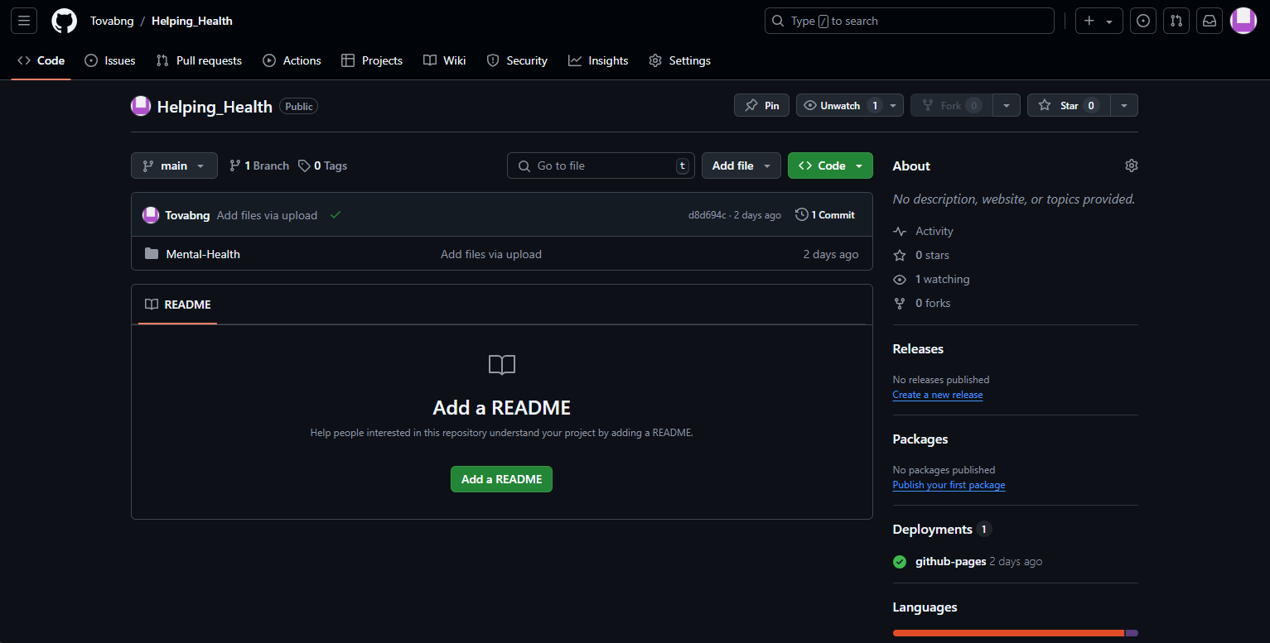

Then this Image above show my successful attempt at uploading my file to github as I created a new repository but with the same name as the unsuccessful one but this I put it as public which allowed me to go further than I did before

**Part 4: Develop/Test Outcome**

|  |
| --- |
| This is a photo of the start of the template that I used for the website I created. I found this template while searching for one in w3schools. |

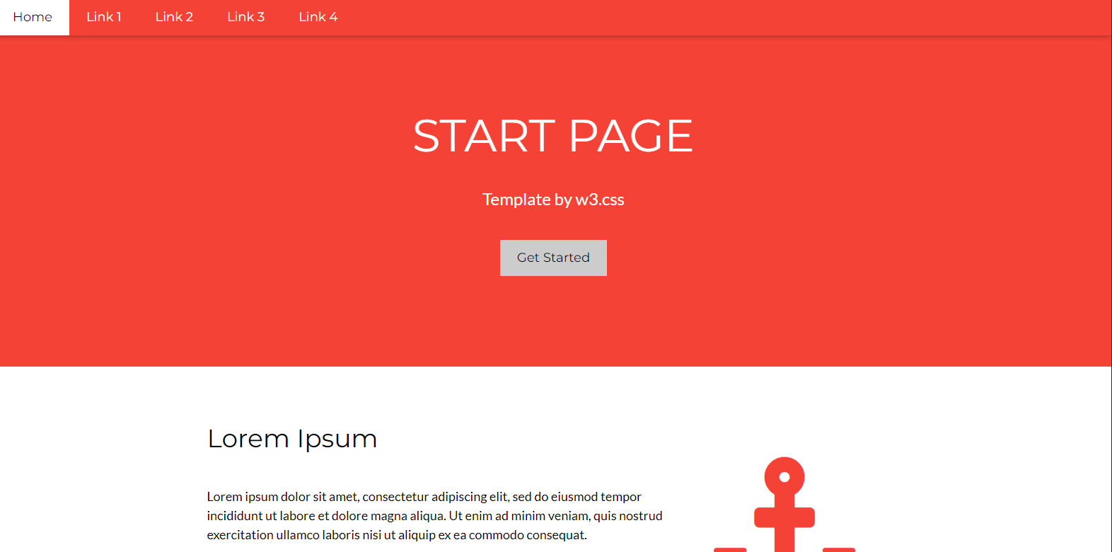

|  |
| --- |
| This was my website after a lot of changes including the colour, pictures and links on the navigation bar. This took me some time as a lot of these changes were challenges due to how I’d had to learn on how to do it. |

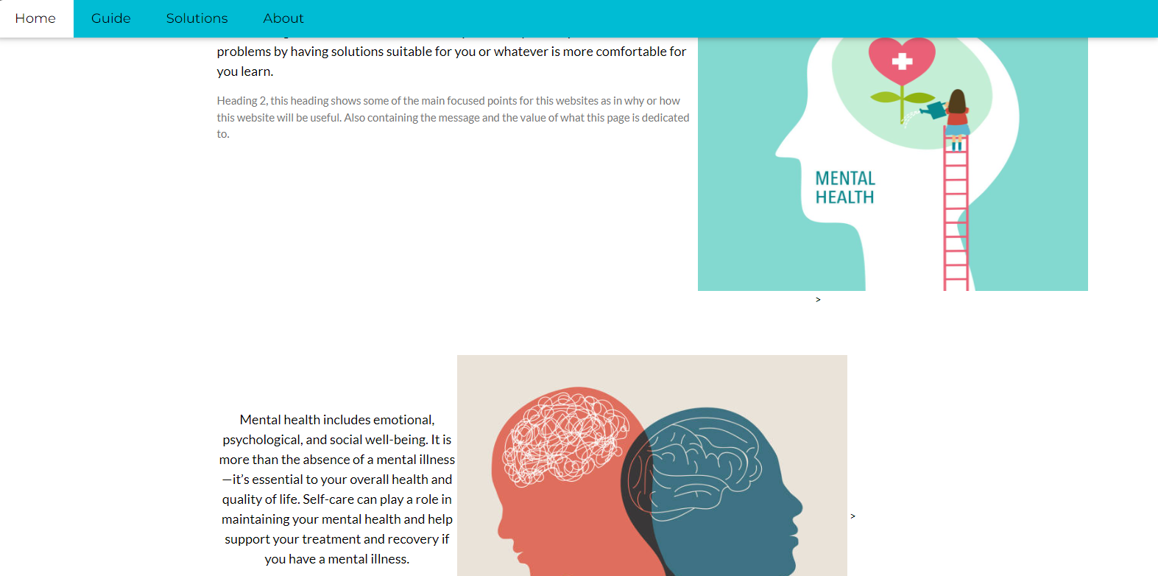

|  |
| --- |
| This was my first draft of my website as I only changed the information boxes with my own that related to my topic and what my website has to provide. And as you can see the coffee cup and anchor were still there because this was when I first started and I didn’t know how to remove them same problem as why the colour is still the same as well |

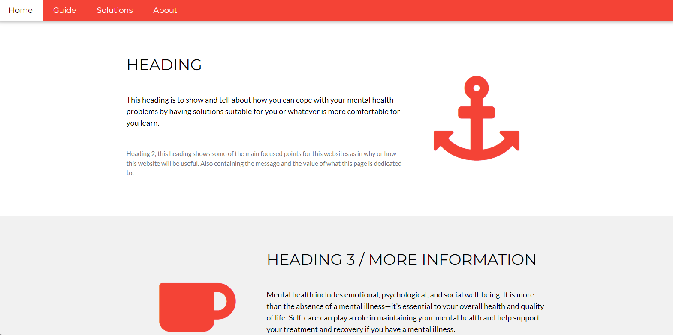

**Part 5: Relevant implications**

Functionality:

**My website worked the way I wanted it by having a navigation bar that had easy access towards getting to the information that my website had to provide. This website can also be viewed multiple devices such as phones, laptops, computers etc.**

Health and safety:

**It is crucial to provide accurate, evidence-based information as misinformation can lead to harmful decisions, so including sources and references enhances credibility. Also addressing mental health in a culturally aware manner can enhance safety for diverse users, ensuring that all individuals feel represented and respected and to do this I have included information how mental health can be a problem in someone’s life which can change someone’s perspective on the website.**

Legal:

**The website can be protected from liability by making it clear that the content is not a replacement for expert medical advice, diagnosis, or treatment. Users should be advised to consult with trained experts for assistance. To avoid copyright infringement, it's also important to make sure that all content—text, photos, and videos—is either original, licensed, or appropriately sourced.**

Social

**Part 6: Evaluate**

**Part 7: Present your Outcome**

**Part 8: Reporting.**